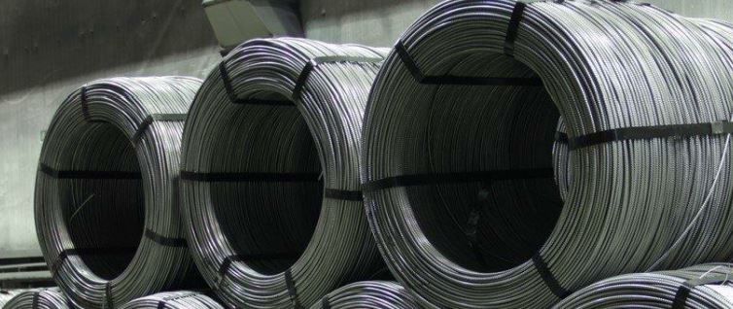

Information about the product

Reinforcing steel with ribbed surface in coils (in accordance with product standards) obtained from scrap melted in an electric arc steelmaking furnace followed by hot rolling and cold working with a periodic profile. Designed for reinforcing reinforced concrete structures of buildings and structures. The composition of steel reinforcing products does not change during use.

Information about the company

NLMK-METALWARE is one of the leading manufacturers of low-carbon hardware products in the Russian market. NLMK-Metiz manufactures wire, nails and self-tapping screws. NLMK-Metiz considers sustainable development as its social mission.

Climate declaration

The table below shows the carbon footprint of the product, calculated as carbon dioxide equivalents (kg CO2 eq.) for 1 kg of сold-formed ribbed steel reinforcement steel coiled bars.
 | Production  A1-A3 | Installation  A4-A5
GWP-fossil | 5.59E-01 kg CO₂-eq | 4.62E-02 kg CO₂-eq
GWP-biogenic | 0.00E+00 kg CO₂-eq | 0.00E+00 kg CO₂-eq
GWP-luluc | 8.31E-05 kg CO₂-eq | 1.67E-04 kg CO₂-eq
GWP Total | 5.59E-01 kg CO₂-eq | 4.63E-02 kg CO₂-eq

 | Disposal  C1-C4 | Reuse/recovery/  recycle  D
GWP-fossil | 1.38E-02 kg CO₂-eq | -8.18E-02kg CO₂-eq
GWP-biogenic | 0.00E+00 kg CO₂-eq | 0.00E+00 kg CO₂-eq
GWP-luluc | 1.06E-04 kg CO₂-eq | 2.33E-06 kg CO₂-eq
GWP Total | 1.39E-02 kg CO₂-eq | -8.18E-02kg CO₂-eq

Other environmental impacts

For the full EPD, see www.environdec.com and www.epdrussia.org.

Contact information

https://metiz.nlmk.com/en/

metiz@nlmk.com

+7 (34369) 6-24-00

